**Conditional operators in c language.**

Conditional operators are only ternary operators in c language. Like there are some unary operators, binary operators, in the same way, ternary operators work on 3 operands.

Syntax:

**Boolean Statement? Statement 1(Executed if Boolean condition is true)** : **Statement 2 (Executed if Boolean condition is false)**

1. If there are more than 1 statement in the place of statement 1 or 2, then they will be separated by commas (,).
2. No semicolon will be used for terminating statements. The semicolon will only be used at last of else statement.

**Priority of operators**

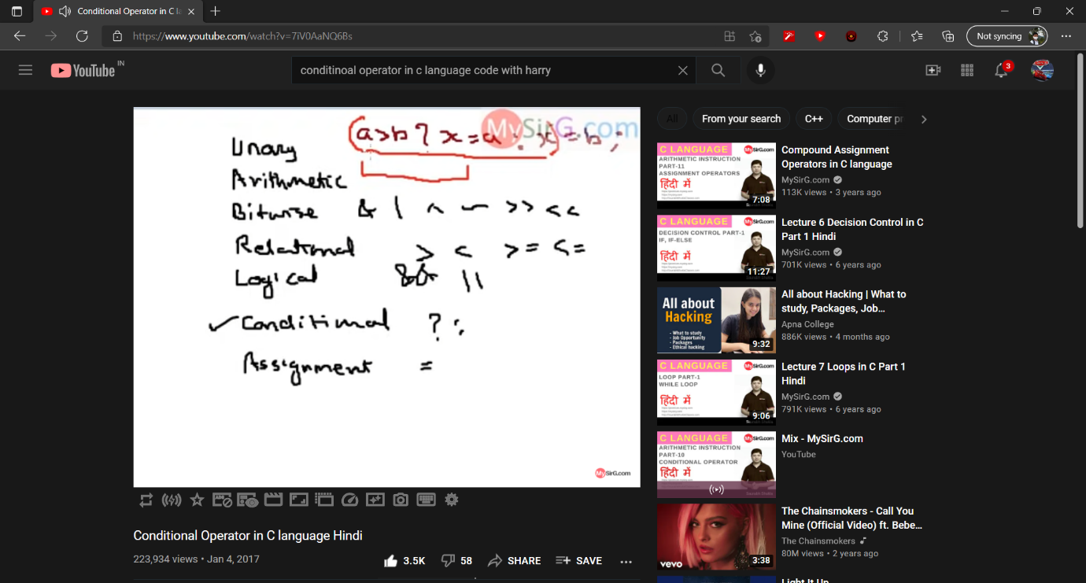

**This is the priority of operators in c language.**

**For example we wrote:**

**Int A = 4, b=5;**

**a>b? x = a:x = b;**

**Here this will not execute like we are thinking. a>b? x = a:x = b; The underlined portion will be treated as a single statement, as priority of assignment operator is extremely low (lower than that of conditional operators). So to prevent this from happening, we must use brackets for telling the compiler what we are trying to execute.**

**So instead of the above statement, it must be written like this:**

**a>b? x=a: (x=b) Here we used brackets to tell compiler what we are trying to tell it.**